Research - ICOM 4998 (March 22-26)

Solar District Cup

Jeziel E. Torres Vazquez

Email: [jeziel.torres1@upr.edu](mailto:jeziel.torres1@upr.edu)

**Abstract:** This week the OpenDss Team connected the Aurora outputs that the design team provided. With this it can be determined if the circuit is stable.

**1 Introduction**

Renewable energy systems are the future. Because of this there is a lot of research and advancements in this area. One of the most important parts of a solar system is the stabilization of the circuit. If there is a part that doesn't meet the requirements the entire systems can be damaged and not work as intended. The team is going to work on connecting the productions of the PV arrays to OpenDss. This could start some overloads and overvoltages but it is required to see if the system is stable.

**2 Work done in the week**

For this week the Distribution System Impact Analysis was working to connect the outputs of Aurora Solar. This program was used by the design team to stimulate the production of the Solar Panels arrays. There were 12,029 Solar Panels. This was distributed by their respected buildings. This is the total panels used, but the total for each building may vary depending on the design the team created.

Each Solar Panels array is connected to their respected building transformers. This will reduce the overloads because if the entire production is connected to only one transformer it could explode.

To connect the outputs in OpenDss the excel file has to be located. After this the loadshapes of each pv array is assigned a with its excel production file. The simulation in OpenDss starts and will create an excel file that will export any overloads and overvoltages in the systems.

When the team ran the simulations with the outputs that the design team provided the circuit ran into some trouble. The excel file created shows that there are occurring overloads and overvoltages in almost every transformer. This is not good because the system is not behaving as intended. This could create damaged or even hazardous situations.

The team planned a meeting to try solving these problems. The first step was to check if the outputs were given in the right units. These units must be kW/h. If there were in other units this could be the problem, but unfortunately it wasn't the problem. The next step was to check if the outputs were in a 0 to ratio. The team coded the lines needed to forzed the outputs to the corresponding ratios. This didn't work either. The last step was to ask the design team to downsize the design because it was too big for the transformers. The team, after trying every possible solution opted to ask the design team for this dowsized.

**3 Graphs, tables, and picture**

Here is the production for every PV array corresponding to the building.

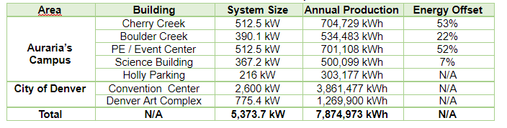

**4 Conclusion**

After trying every possible solution the system still had overloads and overvoltages. This is a real problem because the circuit is not working as intended. This is a problem that needs to be fixed fast and well. The Distribution System Impact Analysis team is going to keep searching for possible solutions.